ASSIGNMENT-6
Subject – Computer Science Workshop-1(CSE 2141)
NAME – DEEPTESH ROUT
Registration Number – 2341018166
Section – 23412G1 Branch – B. Tech (CSE)

/*Q1. Write a program to convert an integer to an Integer object.
- Autoboxing (b) Using Constructor

JAVA CODE

package mypackage;

public class ASS6_Q1 {
public static void main(String[] args) {
int num = 42;

Integer integerAutoboxed =num;
System.out.println("Integer object (using autoboxing): " + integerAutoboxed);

Integer integerUsingConstructor = new Integer(num);
System.out.println("Integer object (using constructor): " + integerUsingConstructor);
}
}

OUTPUT

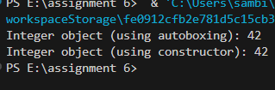

Q2. Write a program to convert a float to a Float object. (a) Autoboxing (b) Using Constructor

JAVA CODE :-

package mypackage;

public class ASS6_Q2 {
public static void main(String[] args) {
float num = 42;

Float floatAutoboxed =num;
System.out.println("Float object (using autoboxing): " + floatAutoboxed);

@SuppressWarnings("removal")
Float floatUsingConstructor = new Float(num);
System.out.println("Integer object (using constructor): " + floatUsingConstructor);
}
}

OUTPUT :-

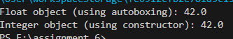

Q3. Write a program to convert a double to a Double object. (a) Autoboxing (b) Using Constructor

JAVA CODE :-

package mypackage;

public class ASS6_Q3 {
public static void main(String[] args) {
Double num = 42.0d;

Double doubleAutoboxed =num;
System.out.println("Double object (using autoboxing): " + doubleAutoboxed);

@SuppressWarnings("removal")
Double doubletUsingConstructor = new Double(num);
System.out.println("Double object (using constructor): " + doubletUsingConstructor);
}
}

OUTPUT:-

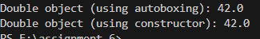

Q4. Write a program to convert a boolean to a Boolean object. (a) Autoboxing (b) Using Constructor

JAVA CODE

package mypackage;

public class ASS6_Q4 {
public static void main(String[] args) {
boolean num = true;

Boolean booleanAutoboxed =num;
System.out.println("Boolean object (using autoboxing): " + booleanAutoboxed);

@SuppressWarnings("removal")
Boolean booleanUsingConstructor = new Boolean(num);
System.out.println("Boolean object (using constructor): " + booleanUsingConstructor);
}
}

OUTPUT :-

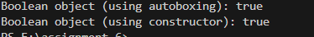

Q5. Write a program to read an integer as a string and convert it to an Integer object.

JAVA CODE

package mypackage;

public class ASS6_Q5 {
public static void main(String args[]) {
String s = "10";

Integer integerObject = Integer.valueOf(s);
System.out.println("String \"" + s + "\" converted to Integer object is: " + integerObject);
}
}

OUTPUT :-

Q6. Write a program to read a float as a string and convert it to a Float object.

JAVA CODE :-

package mypackage;
import java.util.*;
public class ASS6_Q6 {
public static void main(String args[]) {
Scanner sc=new Scanner(System.in);
System.out.println("Enter a string to convert it to ");
String s = sc.next();

Float floatObject = Float.parseFloat(s);
System.out.println("String \"" + s + "\" converted to Float object is: " +floatObject);
}
}

OUTPUT :-
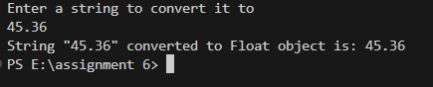

Q7. Write a program to read a double as a string and convert it to a Double object.

JAVA CODE

package mypackage;
import java.util.*;
public class Dec16 ASS6_Q7 {
public static void main(String args[]) {
Scanner sc=new Scanner(System.in);
System.out.println("Enter a string to convert it to ");
String s = sc.next();

Double doubleObject = Double.parseDouble(s);
System.out.println("String \"" + s + "\" converted to Double object is: " +doubleObject);
}
}

OUTPUT :-

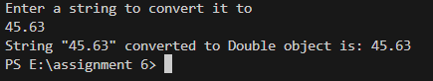

Q8. Write a program to read a boolean as a string and convert it to a Boolean object. Explain the concept of converting a base data type to an object type(Wrapping) using the valueOf() method.

JAVA CODE :-

package mypackage;
import java.util.*;
public class ASS6_Q8 {
public static void main(String args[]) {
Scanner sc=new Scanner(System.in);
System.out.println("Enter a string to convert it to ");
String s = sc.next();

Boolean booleanObject = Boolean.parseBoolean(s);
System.out.println("String \"" + s + "\" converted to Boolean object is: " +booleanObject);
}
}

OUTPUT :-
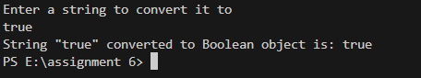

Q9. Write a program that reads to convert int, float, double, and boolean as string types and convert them to respective object types using the valueOf method.

JAVA CODE :-

package mypackage;
import java.util.*;
public class ASS6_Q9 {
public static void main(String args[]) {
Scanner sc=new Scanner(System.in);
System.out.println("Enter a string to convert it to integer");
String si = sc.next();
System.out.println("Enter a string to convert it to float");
String sf = sc.next();
System.out.println("Enter a string to convert it to double");
String sd = sc.next();
System.out.println("Enter a string to convert it to boolean");
String sb = sc.next();

Integer integerObject = Integer.valueOf(si);
Float floatObject = Float.valueOf(sf);
Double doubleObject = Double.valueOf(sd);
Boolean booleanObject = Boolean.valueOf(sb);
System.out.println("String \"" + si + "\" converted to Integer object is: " + integerObject);
System.out.println("String \"" + sf + "\" converted to Float object is: " + floatObject);
System.out.println("String \"" + sd + "\" converted to Double object is: " + doubleObject);
System.out.println("String \"" + sb + "\" converted to Boolean object is: " + booleanObject);
}
}

OUTPUT :-

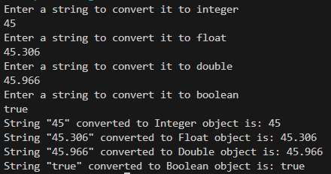

Q10. Write a program to design a simple calculator (only +,-,*,/ operations). The calculator works as follows: Input: ”123+345” Output: Sum=468 Input: ”5*10” Output: mul=50 Explain the concept of converting object type to base type. Explain the method used to do so.

package mypackage;

import java.util.Scanner;

public class ASS6_Q10{
public static void main(String[] args) {
Scanner scanner = new Scanner(System.in);

// Take user input in the format "number1operatornumber2"
System.out.print("Enter an operation (e.g., 123+345): ");
String input = scanner.nextLine();

// Variables to store parsed values
int num1 = 0, num2 = 0;
char operator = '\0';

// Parse the input to separate the numbers and the operator
for (int i = 0; i < input.length(); i++) {
if (input.charAt(i) == '+' || input.charAt(i) == '-' || input.charAt(i) == '*' || input.charAt(i) == '/') {
operator = input.charAt(i);
num1 = Integer.parseInt(input.substring(0, i)); // Convert first part to integer
num2 = Integer.parseInt(input.substring(i + 1)); // Convert second part to integer
break;
}
}

// Perform the operation and display the result
switch (operator) {
case '+':
System.out.println("Sum=" + (num1 + num2));
break;
case '-':
System.out.println("Sub=" + (num1 - num2));
break;
case '*':
System.out.println("Mul=" + (num1 * num2));
break;
case '/':
if (num2 != 0) {
System.out.println("Div=" + (num1 / num2));
} else {
System.out.println("Error: Division by zero");
}
break;
default:
System.out.println("Invalid operator");
}

scanner.close();
}
}

EXPLAINATION OF THE concept of converting object type to base type. Explain the method used to do so.

/*Here is a Java program for a simple calculator that can handle addition (`+`), subtraction (`-`), multiplication (`*`), and division (`/`).
The program uses basic string manipulation to parse the input and performs the requested operation.
Following the program, an explanation of converting object types to base types is provided.

### Explanation of Converting Object Types to Base Types in Java
In Java, primitive data types (like `int`, `float`, etc.) and their corresponding wrapper classes (like `Integer`, `Float`, etc.) are distinct.
Wrapper classes are object representations of the primitive types. Conversion between these types is done using:

1. **Unboxing**: This refers to converting an object type (like `Integer`) into its base type (`int`). It happens automatically in Java because of **autoboxing and unboxing** introduced in Java 5.
- Example:
```java
Integer obj = Integer.valueOf(42); // Wrapper class object
int baseType = obj; // Automatic unboxing to primitive
```

2. **Explicit Parsing**: When working with `String` inputs, you often need to convert these to base types. This is done using methods like `Integer.parseInt(String)` or `Double.parseDouble(String)`.
- Example from the program:
```java
num1 = Integer.parseInt(input.substring(0, i)); // Converts String to int
```

### Method Used in the Program
The program uses the `Integer.parseInt(String)` method to explicitly convert the string representation of a number into its primitive type (`int`). This is necessary because user input from the console is always read as a `String`. The method ensures that mathematical operations can be performed on the numeric values. */

Q11. Write a program that reads a double number as a sting and converts it to a double base type.

JAVA CODE :-

package mypackage;
import java.util.Scanner;

public class ASS6_Q11 {

public static void main(String[] args) {
Scanner scanner = new Scanner(System.in);

System.out.print("Enter a double value as a string: ");
String str = scanner.nextLine();

try {
double doubleValue = Double.parseDouble(str);
System.out.println("The string \"" + str + "\" converted to a double is: " + doubleValue);
} catch (NumberFormatException e) {
System.out.println("Error: Invalid input. Please enter a valid double value.");
}
scanner.close();
}
}

OUTPUT : -

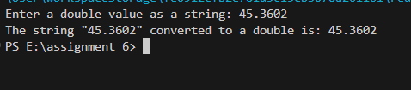

Q12. Write a program that reads an integer number as a sting and converts it to an int base type. Explain the following concepts:
• Arrays
• Conditional Statements
• Loops

JAVA CODE :-

package mypackage;
import java.util.Scanner;

public class ASS6_Q12 {

public static void main(String[] args) {
Scanner scanner = new Scanner(System.in);

System.out.print("Enter a integer value as a string: ");
String str = scanner.nextLine();

try {
int integerValue = Integer.parseInt(str);
System.out.println("The string \"" + str + "\" converted to a integer is: " + integerValue);
} catch (NumberFormatException e) {
System.out.println("Error: Invalid input. Please enter a valid integer value.");
}
scanner.close();
}
}

EXPLAINATION

Explanation of Concepts
Arrays
- Definition: Arrays are data structures that store multiple values of the same type in a single variable. Each element in an array is accessed using an index.
- Example:
- int[] numbers = {1, 2, 3, 4};
- System.out.println(numbers[2]); // Outputs 3
Conditional Statements
- Definition: Conditional statements allow the program to execute certain code blocks based on whether a condition is true or false.
- Types: if, else if, else, and switch.
- Example:
- int number = 10;
- if (number > 5) {
- System.out.println(\"Number is greater than 5\");
- } else {
- System.out.println(\"Number is 5 or less\");
- }
Loops
- Definition: Loops are used to repeatedly execute a block of code as long as a specified condition is true.
- Types: for, while, and do-while.
- Example:
- for (int i = 0; i < 5; i++) {
- System.out.println(\"Iteration: \" + i);
- }
Summary
The program converts a string representation of a number into its integer form using Integer.parseInt. It employs conditional statements (try-catch) to handle invalid input gracefully. Arrays, loops, and conditionals are core constructs in Java programming, enabling efficient data management and control flow.

OUTPUT :-

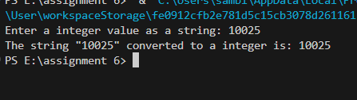

Q13. Write a program that prompts the user to input a positive integer. It should then print the multiplication table of that number.

JAVA CODE

import java.util.Scanner;

public class MultiplicationTable {
public static void main(String[] args) {
Scanner scanner = new Scanner(System.in);

// Prompt the user to enter a positive integer
System.out.print("Enter a positive integer: ");
int number = scanner.nextInt();

// Validate the input
if (number <= 0) {
System.out.println("Error: Please enter a positive integer.");
} else {
// Print the multiplication table
System.out.println("Multiplication Table for " + number + ":");
for (int i = 1; i <= 10; i++) {
System.out.println(number + " x " + i + " = " + (number * i));
}
}

scanner.close();
}
}

OUTPUT :-

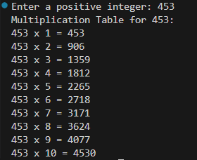

Q14. Write a java program to calculate HCF and LCM of Two given number.

JAVA CODE
import java.util.Scanner;
public class HCFAndLCM {
public static int calculateHCF(int num1, int num2) {
while (num2 != 0) {
int temp = num2;
num2 = num1 % num2;
num1 = temp;
}
return num1;
}
public static int calculateLCM(int num1, int num2, int hcf) {
return (num1 * num2) / hcf;
}
public static void main(String[] args) {
Scanner scanner = new Scanner(System.in);
System.out.print("Enter the first number: ");
int num1 = scanner.nextInt();
System.out.print("Enter the second number: ");
int num2 = scanner.nextInt();
int hcf = calculateHCF(num1, num2);
int lcm = calculateLCM(num1, num2, hcf);
System.out.println("HCF of " + num1 + " and " + num2 + " is: " + hcf);
System.out.println("LCM of " + num1 + " and " + num2 + " is: " + lcm);
scanner.close();
}
}

OUTPUT
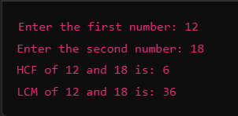

Q15 .Write a program to calculate the sum of following series where n is input by user. 1 + 1/2 + 1/3 + 1/4 + 1/5 +…………1/n

import java.util.Scanner;
public class SeriesSum {

public static void main(String[] args) {
Scanner scanner = new Scanner(System.in);

// Input the value of n
System.out.print("Enter the value of n: ");
int n = scanner.nextInt();

// Validate input
if (n <= 0) {
System.out.println("Please enter a positive integer.");
return;
}

double sum = 0.0;

// Calculate the sum of the series
for (int i = 1; i <= n; i++) {
sum += 1.0 / i;
}

// Output the result
System.out.printf("The sum of the series is: %.6f\n", sum);

scanner.close();
}
}

OUTPUT :-
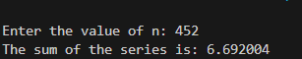

Q16. Write a program to enter the numbers till the user wants and at the end the program should display the largest and smallest numbers entered.

JAVA CODE :-
import java.util.Scanner;

public class ASS6_Q16 {
public static void main(String[] args) {
Scanner scanner = new Scanner(System.in);
int largest = Integer.MIN_VALUE;
int smallest = Integer.MAX_VALUE;
char choice;

do {
System.out.print("Enter a number: ");
int number = scanner.nextInt();

// Update largest and smallest
if (number > largest) {
largest = number;
}
if (number < smallest) {
smallest = number;
}

System.out.print("Do you want to enter another number? (y/n): ");
choice = scanner.next().toLowerCase().charAt(0);

} while (choice == 'y');

// Display results
System.out.println("Largest number entered: " + largest);
System.out.println("Smallest number entered: " + smallest);

scanner.close();
}
}

OUTPUT :-

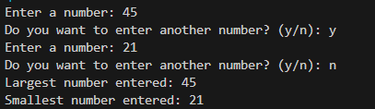

Q17. . Write a java program to find the minimum and maximum element in an array.

JAVA CODE :-

import java.util.Scanner;

public class ASS6_Q17 {
public static void main(String[] args) {
Scanner scanner = new Scanner(System.in);

// Input: Array size
System.out.print("Enter the size of the array: ");
int size = scanner.nextInt();

// Input: Array elements
int[] array = new int[size];
System.out.println("Enter " + size + " elements:");
for (int i = 0; i < size; i++) {
array[i] = scanner.nextInt();
}

// Initialize min and max
int min = array[0];
int max = array[0];

// Traverse the array to find min and max
for (int i = 1; i < size; i++) {
if (array[i] < min) {
min = array[i];
}
if (array[i] > max) {
max = array[i];
}
}

// Output the results
System.out.println("Minimum element: " + min);
System.out.println("Maximum element: " + max);

scanner.close();
}
}

OUTPUT
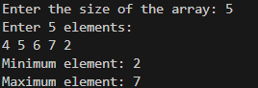

Q18. Write java program to find the Kth largest and Kth smallest number in an array.

JAVA CODE

import java.util.Arrays;
import java.util.Scanner;

public class ASS6_Q18 {
public static void main(String[] args) {
Scanner scanner = new Scanner(System.in);

// Input: Array size
System.out.print("Enter the size of the array: ");
int size = scanner.nextInt();

// Input: Array elements
int[] array = new int[size];
System.out.println("Enter " + size + " elements:");
for (int i = 0; i < size; i++) {
array[i] = scanner.nextInt();
}

// Input: Value of K
System.out.print("Enter the value of K: ");
int k = scanner.nextInt();

// Check if K is valid
if (k > size || k <= 0) {
System.out.println("Invalid value of K. It should be between 1 and " + size);
return;
}

// Sort the array
Arrays.sort(array);

// Find K-th smallest and K-th largest
int kthSmallest = array[k - 1];
int kthLargest = array[size - k];

// Output the results
System.out.println("K-th smallest element: " + kthSmallest);
System.out.println("K-th largest element: " + kthLargest);

scanner.close();
}
}

OUTPUT :-
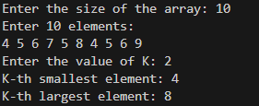

Q19. Write a java program to reverse the given array. (Without using Library function)

JAVA CODE

import java.util.Scanner;

public class ReverseArrayWithWhileLoop {
public static void main(String[] args) {
Scanner scanner = new Scanner(System.in);

// Input: Array size
System.out.print("Enter the size of the array: ");
int size = scanner.nextInt();

// Input: Array elements
int[] array = new int[size];
System.out.println("Enter " + size + " elements:");
for (int i = 0; i < size; i++) {
array[i] = scanner.nextInt();
}

// Reverse the array using a while loop
int left = 0;
int right = size - 1;
while (left < right) {
// Swap elements at left and right indices
int temp = array[left];
array[left] = array[right];
array[right] = temp;

// Move the indices towards each other
left++;
right--;
}

// Output: Reversed array
System.out.println("Reversed array:");
for (int element : array) {
System.out.print(element + " ");
}

scanner.close();
}
}

OUTPUT :-

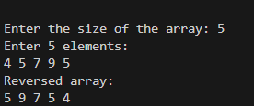

Q20. Write a java program to sort the given array. (Without using Library function)

JAVA CODE :-

import java.util.Scanner;

public class ASS6_Q20 {
public static void main(String[] args) {
Scanner scanner = new Scanner(System.in);

// Input: Array size
System.out.print("Enter the size of the array: ");
int size = scanner.nextInt();

// Input: Array elements
int[] array = new int[size];
System.out.println("Enter " + size + " elements:");
for (int i = 0; i < size; i++) {
array[i] = scanner.nextInt();
}

// Sorting the array using Bubble Sort
for (int i = 0; i < size - 1; i++) {
for (int j = 0; j < size - i - 1; j++) {
if (array[j] > array[j + 1]) {
// Swap array[j] and array[j+1]
int temp = array[j];
array[j] = array[j + 1];
array[j + 1] = temp;
}
}
}

// Output: Sorted array
System.out.println("Sorted array:");
for (int element : array) {
System.out.print(element + " ");
}

scanner.close();
}
}

OUTPUT :-
